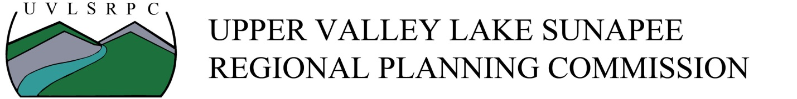

Position Title: Planner
Status: Salary, Non-Exempt, Full-time (40 hours per week) – office and/or remote work
Location: Lebanon, New Hampshire
Salary Range: $55,000 - $58,000 annually based on skills and experience.
Benefits: Benefits include paid time off/sick time (accrued 3.3846 hrs/week), paid holidays, flexible work schedule, health care plan at no cost to employee, vision and dental plan, long and short-term disability, life insurance, parental leave, and up to 6% retirement match after one year
Posting Date: May 8, 2023
Start Date: June/July
To Apply: Submit a cover letter and resume to info@uvlsrpc.org
Application Deadline: Applications will be accepted until the position is filled. UVLSRPC will be reviewing applications as they arrive.
Position Description
The Planner position at UVLSRPC is an essential part of our Team. The position offers opportunities to work in all sectors of regional and municipal planning in collaboration with other staff, community partners, and independently.
What are we looking for?
UVLSRPC is looking for an energized individual who is eager to support multiple projects at once. We are looking for an individual that has a strong interest and/or background in transportation, housing, and land-use topics. Ideally, this person has a strong willingness to learn and the ability to lead a variety of different planning sectors. This individual will be expected to work with other staff and independently on various tasks.
Initial project work will include supporting the Long-Range Transportation Plan, providing technical assistance to our communities, preparing zoning amendments for municipal boards, and hosting public engagement events.

Preferred Experience
Master of Arts/Science in urban and regional planning, transportation planning, public administration, public policy, business administration, or related degree. 3 years of planning work experience and ACIP preferred. Educational, work, or volunteer experience in planning, community development, or transportation can substitute for the preferred work experience. UVLSRPC provides training and professional development opportunities for all employees.
Skills/Knowledge
- Knowledge of regional planning principles and practices
- Expertise in qualitative and quantitative research and data collection methods and practices
- Cooperatively work with elected officials, staff, volunteers, and the general public
- Ability to prepare well-written reports for publication and presentation
- Ability to work independently, within teams, on multiple projects simultaneously, and meet deadlines
- Creatively solve problems and build consensus among different stakeholders
- Ability to speak effectively in public settings and give public presentations
- Ability to facilitate meetings and participate effectively in meetings
- Knowledge of Microsoft Publisher, PowerPoint, Excel and related software tools for analysis and communication
- Effective project management and organizational skills
- Skills and knowledge in ArcGIS and mapping

Responsibilities
- Lead all stages of the planning process, including, but not limited to, data collection, analysis, synthesis, visioning, and writing formal plans and studies
- Develop new and updated municipal and regional plans and programs
- Manage the collection of transportation-related data, including stream crossing assessments, traffic counts, and turning movement counts (Traffic data collection may require work outside of regular business hours.)
- Review development proposals, permit applications, and site plans for conformance with local ordinances and regulations
- Organize, prepare, and present plans, reports, and analyses to municipal boards, commissions, and the public
- Prepare subdivision/land use development reviews, zoning analysis requests, and zoning amendments as requested by member municipalities
- Prepare grant applications in a variety of fields to implement new projects and studies

