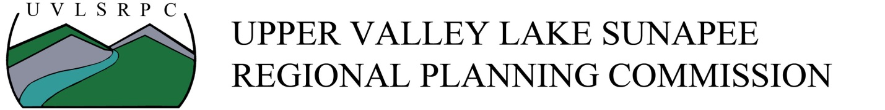

Position Title: Associate Planner
Status: Salary, Non-Exempt, Full-time (40 hours per week) – office and/or remote work
Location: Lebanon, New Hampshire
Salary Range: $51,000 - $54,000 annually based on skills and experience.
Benefits: Benefits include paid time off/sick time (accrued 3.3846 hrs/week), paid holidays, flexible work schedule, health care plan at no cost to employee, vision and dental plan, long and short-term disability, life insurance, parental leave, and up to 6% retirement match after one year
Posting Date: May 8, 2023
Start Date: June/July
To Apply: Submit a cover letter and resume to info@uvlsrpc.org
Application Deadline: Applications will be accepted until the position is filled. UVLSRPC will be reviewing applications as they arrive.
Position Description
The Associate Planner position at UVLSRPC is an essential part of our Team. The position offers opportunities to work in all sectors of regional and municipal planning in collaboration with other staff, community partners, and independently.
What are we looking for?
UVLSRPC is looking for an energized individual that is willing to learn and support multiple projects at once. We are looking for an individual ready to learn and support a variety of different planning sectors such as transportation, housing, economic development, land-use, hazard mitigation, and community development. This individual will be expected to work with other staff and independently on various tasks. There is potential in this position to lead projects and communities through various stages of planning and community engagement.
Initial project work will include supporting the Long-Range Transportation Plan, assisting with field work (stream crossing assessments, traffic counts, and bicycle counts), creating outreach materials, and assisting with municipal regulatory audits.
Preferred Experience
Bachelor of Arts or Science in urban and regional planning, public policy, public administration, business administration, community development, economics, environmental science, environmental studies, historic preservation, transportation planning or related degree preferred. 0 to 1 years of educational, work, or volunteer experience in planning or community development. Entry-level candidates will be considered. UVLSRPC provides training and professional development opportunities for all employees.
Skills/Knowledge
- Knowledge of planning principles and practices applications
- Knowledge of qualitative and quantitative research and data collection methods and practices
- Interest in regional planning and other topics (transportation, land-use, economic development, housing, environment, hazard mitigation)
- Ability to effectively communicate with elected officials, staff, volunteers, and the general public
- Ability to prepare well-written reports for publication and presentation
- Ability to work independently, within teams, on multiple projects simultaneously, and meet deadlines
- Ability to solve problems and build consensus among different stakeholders
- Knowledge of Microsoft Publisher, PowerPoint, Excel and related software tools for analysis and communication
- Effective project management and organizational skills
- Skills and knowledge in ArcGIS and mapping is a plus
- Ability to generate social media content and outreach materials

Responsibilities
- Assist with all stages of planning development, including, but not limited to, data collection, analysis, synthesis, visioning, and creating formal plans and studies
- Assist with supporting new and updated municipal and regional plans and programs
- Assist with the collection of transportation-related data, including stream crossing assessments, traffic counts, and turning movement counts (Traffic data collection may require work outside of regular business hours.)
- Assist in reviewing development proposals, permit applications, and site plans for conformance with local ordinances and regulations
- Assist with the organization of plans, reports, and analyses to municipal boards, commissions, and the public
- Assist with the preparation of grant applications in a variety of fields to implement new projects and studies
- Provide technical assistance with project development

